# PATIENT TEMPERATURE MONITORING SYSTEM

## A PROJECT REPORT

***Submitted by***

**PRATHEEPA R (2116210701192) MUKHILAN S S (2116210701169)**

**MOHANAPRIYA E (2116210701164)**

***in partial fulfillment for the award of the degree of***

**BACHELOR OF ENGINEERING**

***in***

## COMPUTER SCIENCE AND ENGINEERING



**RAJALAKSHMI ENGINEERING COLLEGE ANNA UNIVERSITY, CHENNAI**

**MAY 2024**

# RAJALAKSHMI ENGINEERING COLLEGE, CHENNAI

**BONAFIDE CERTIFICATE**

Certified that this Thesis titled **“PATIENT TEMPERATURE MONITORING SYSTEM**” is the bonafide work of “**PRATHEEPA R (2116210701192), MUKHILAN S S (2116210701169), MOHANAPRIYA E**

**(2116210701164)”** who carried out the work under my supervision. Certified further that to the best of my knowledge the work reported herein does not form part of any other thesis or dissertation on the basis of which a degree or award was conferred on an earlier occasion on this or any other candidate.

## SIGNATURE

Mr., Gunasekaran S M.Tech., (Ph.D)

## PROJECT COORDINATOR

Assistant Professor (SG)

Department of Computer Science and Engineering Rajalakshmi Engineering College

Chennai - 602 105

Submitted to Project Viva-Voce Examination held on **_**

**Internal Examiner External Examine**r

# ABSTRACT

The IoT Patient Temperature Monitoring System represents a pivotal advancement in healthcare technology, aiming to revolutionize patient care in intensive care units (ICUs). This system integrates state-of-the-art sensor technology with IoT capabilities to provide continuous and accurate monitoring of patient body temperature. Through a comprehensive literature survey, encompassing various sensor technologies, wireless communication protocols, user interface design principles, and regulatory considerations, the project is meticulously designed to meet the highest standards of performance, reliability, and regulatory compliance. Leveraging Arduino microcontroller technology and wireless communication protocols, the system enables seamless data transmission and integration with existing healthcare information systems, ensuring interoperability and data security. User- centered design principles are incorporated to create an intuitive and user-friendly interface for healthcare professionals, facilitating efficient temperature monitoring and timely intervention. The system's potential for remote patient monitoring and telemedicine applications is explored, offering opportunities to enhance patient outcomes and healthcare delivery models. By adhering to rigorous clinical validation processes and regulatory requirements, the IoT Patient Temperature Monitoring System promises to significantly improve patient safety, clinical effectiveness, and operational efficiency in ICU environments.

# ACKNOWLEDGMENT

First, we thank the almighty god for the successful completion of the project. Our sincere thanks to our chairman **Mr. S. Meganathan B.E., F.I.E.,** for his sincere endeavor in educating us in his premier institution. We would like to express our deep gratitude to our beloved Chairperson **Dr. Thangam Meganathan Ph.D.,** for her enthusiastic motivation which inspired us a lot in completing this project and Vice Chairman **Mr. Abhay Shankar Meganathan B.E., M.S.,** for providing us with the requisite infrastructure.

We also express our sincere gratitude to our college Principal,

**Dr. S. N. Murugesan M.E., PhD.,** and **Dr. P. KUMAR M.E., PhD, Director computing and information science , and Head Of Department of Computer Science and Engineering** and our project coordinator **Mr. Gunasekaran S M M.Tech., (Ph.D)** for her encouragement and guiding us throughout the project towards successful completion of this project and to our parents, friends, all faculty members and supporting staffs for their direct and indirect involvement in successful completion of the project for their encouragement and support.

**PRATHEEPA R MUKHILAN S S MOHANAPRIYA E**

## TABLE OF CONTENTS

|  |  |  |
| --- | --- | --- |
| **CHAPTER NO.** | **TITLE** | **PAGE NO.** |
|  | **ABSTRACT** | **iii** |
|  | **LIST OF TABLES**  **LIST OF FIGURES** | **v**  **vii** |

1. **INTRODUCTION 1**
   1. RESEARCH PROBLEM
   2. PROBLEM STATEMENT
   3. SCOPE OF THE WORK
   4. AIM AND OBJECTIVES OF THE PROJECT
   5. RESOURCES
   6. MOTIVATION

## LITERATURE SURVEY 4

* 1. SURVEY
  2. PROPOSED SYSTEM
  3. NEAT ALGORITHM
  4. INFERENCE MECHANISM

## SYSTEM DESIGN 6

* 1. GENERAL
  2. SYSTEM ARCHITECTURE DIAGRAM
  3. DEVELOPMENT ENVIRONMENT
     1. HARDWARE REQUIREMENTS
     2. SOFTWARE REQUIREMENTS
  4. DESIGN OF THE ENTIRE SYSTEM
     1. SEQUENCE DIAGRAM

## STUDY & CONCEPTUAL DIAGRAM’S 11

* 1. CONCEPTUAL DIAGRAM
  2. PROFESSIONAL VALUE OF THE STUDY
  3. PYTHON CODE 12

## RESULTS AND DISCUSSIONS 25

* 1. FINAL OUTPUT
  2. RESULT

## CONCLUSION AND SCOPE FOR

**FUTURE ENHANCEMENT 29**

* 1. CONCLUSION
  2. FUTURE ENHANCEMENT

## REFERENCES 31

|  |  |  |
| --- | --- | --- |
|  | **LIST OF FIGURES** |  |
| **FIGURE NO** | **TITLE** | **PAGE NO** |
| 2.3 | INFERENCE DIAGRAM | 5 |
| 3.1 | SYSTEM ARCHITECTURE | 6 |
| 3.2 | SEQUENCE DIAGRAM | 8 |
| 4.1 | CONCEPTUAL ARCHITECTURE | 11 |
| 5.1 | OUTPUT | 25 |

**CHAPTER 1 INTRODUCTION**

In healthcare facilities, particularly in critical care units like Intensive Care Units (ICUs), continuous monitoring of patient vital signs is paramount for timely intervention and improved patient outcomes. Traditional methods of patient temperature monitoring often involve manual measurements using thermometers, requiring frequent nurse interventions and posing challenges in real-time monitoring.

To address these challenges, we introduce the IoT Patient Temperature Monitoring System, a groundbreaking solution designed to revolutionize patient care. This innovative system leverages the power of Internet of Things (IoT) technology to enable continuous and automated monitoring of patient body temperature, providing healthcare professionals with instant access to vital information.

The IoT Patient Temperature Monitoring System comprises advanced sensors, microcontrollers, and display units integrated into a seamless platform. Two Negative Temperature Coefficient (NTC) thermistors are strategically placed to accurately measure the patient's body temperature. These sensors interface with an Arduino UNO microcontroller, which serves as the central processing unit for data acquisition and control.

Real-time temperature readings are displayed on a Liquid Crystal Display (LCD) panel, offering immediate visibility to healthcare providers. Additionally, the system incorporates an audible alarm in the form of a buzzer, which activates when the temperature surpasses predefined thresholds, alerting nurses to potential abnormalities.

By automating the temperature monitoring process and providing continuous updates, our IoT Patient Temperature Monitoring System enhances the efficiency of healthcare delivery while improving patient care outcomes. Nurses stationed at ICUs and other critical care areas can now focus on delivering timely interventions based on accurate and up-to-date temperature data, leading to enhanced patient safety and well-being.

## PROBLEM STATEMENT

In healthcare settings, particularly in intensive care units (ICUs), the manual monitoring of patient vital signs, including body temperature, poses significant challenges for healthcare providers. Traditional methods of temperature measurement, such as using thermometers, are time-consuming, prone to human error, and often result in delays in detecting critical changes in patient condition. Furthermore, the need for frequent manual interventions by nursing staff can disrupt patient rest and increase workload. To address these challenges and improve patient care outcomes, there is a pressing need for an automated and continuous patient temperature monitoring system that offers real-time monitoring, alerts for abnormal temperature fluctuations, and seamless integration into existing healthcare workflows.

## SCOPE OF THE WORK

The scope of the IoT Patient Temperature Monitoring System project encompasses the development, integration, testing, and deployment of a comprehensive solution tailored for continuous patient temperature monitoring in healthcare environments, particularly intensive care units (ICUs). This includes the design and assembly of hardware components such as NTC thermistors for temperature measurement, LCD panels for real-time display, and buzzer alarms for alerting healthcare providers of abnormal temperature fluctuations. On the software front, the project involves programming the Arduino microcontroller to read sensor data, process temperature readings, and trigger alarms as necessary. System integration efforts focus on seamless interaction between hardware and software components, ensuring accurate temperature monitoring and responsive alarm triggers. Rigorous testing and validation procedures are conducted to verify system functionality, assess performance under various conditions, and solicit user feedback for iterative improvements. Deployment in healthcare settings involves installation, staff training, and continuous monitoring to evaluate system effectiveness and reliability. Documentation and reporting efforts encompass the creation of user manuals, technical documentation, test reports, and a final project report summarizing objectives, methodologies, findings, and recommendations for future enhancements. Through these endeavors, the project aims to deliver a robust and user-friendly solution that enhances patient care by providing timely and accurate temperature monitoring in critical care settings.

## AIM AND OBJECTIVES OF THE PROJECT

The aim of the IoT Patient Temperature Monitoring System project is to develop a comprehensive solution that enhances patient care in healthcare facilities, particularly in intensive care units (ICUs), through continuous and automated monitoring of patient body temperature. This system seeks to streamline temperature monitoring processes, enabling timely intervention by healthcare providers and ultimately improving patient safety and well-being. To achieve this aim, the project has several objectives.

Firstly, it involves the design and development of both hardware and software components, including NTC thermistors, an Arduino microcontroller, an LCD display, and a buzzer alarm, to facilitate continuous temperature monitoring.

Secondly, integration efforts focus on seamlessly combining these components to create a cohesive system capable of accurately measuring and displaying patient temperature in real-time, while also triggering alerts for abnormal temperature readings. Rigorous testing and validation procedures ensure the reliability and effectiveness of the system under various conditions, followed by deployment in healthcare environments for real-world evaluation and user feedback. This feedback is then used to iteratively refine the system, with documentation and reporting providing comprehensive insights into project methodologies, findings, and recommendations for future enhancements. Through these efforts, the project aims to deliver a robust, user-friendly, and impactful solution that significantly improves patient care outcomes in healthcare settings.

## RESOURCES

This project has been developed through widespread secondary research of accredited manuscripts, standard papers, business journals, white papers, analysts' information, and conference reviews. Significant resources are required to achieve an efficacious completion of this project.

Hardware Components: The project requires essential hardware components such as NTC thermistors for temperature sensing, an Arduino microcontroller board for data processing, an LCD display panel for real-time visualization of temperature readings, and a buzzer alarm for alert notifications.

Software Tools: Software tools including the Arduino Integrated Development Environment (IDE) and programming languages like C/C++ are necessary for firmware development and hardware interfacing, enabling the programming of the Arduino microcontroller to process temperature data and trigger alarms.

Budget and Funding: Adequate budget allocation and exploration of potential funding sources such as grants, sponsorships, or institutional support are crucial for acquiring hardware components, software licenses, testing equipment, and educational resources, ensuring the successful execution of the project within financial constraints.

## MOTIVATION

The motivation behind the IoT Patient Temperature Monitoring System project stems from the pressing need to improve patient care and streamline healthcare processes, particularly in critical care environments such as intensive care units (ICUs). Traditional methods of patient temperature monitoring often involve manual measurements using thermometers, which are time-consuming, labor-intensive, and prone to human error. This can lead to delays in detecting critical changes in patient condition and may compromise patient safety.

By developing an automated and continuous temperature monitoring system, the project aims to address these challenges and provide healthcare providers with real-time access to accurate temperature data. This enables timely intervention in case of abnormal temperature fluctuations, allowing healthcare professionals to respond promptly to changes in patient condition and improve patient outcomes.

Furthermore, the IoT Patient Temperature Monitoring System alleviates the burden on nursing staff by reducing the need for manual temperature measurements,

allowing them to focus on other critical tasks and providing more personalized care to patients. Additionally, the system enhances efficiency in healthcare delivery

by facilitating remote monitoring and enabling seamless integration into existing healthcare workflows

**CHAPTER 2 LITRETURE SURVEY**

The study of “IoT” was comprehensive and montages relations and constraints. The main goal of “IoT” is to ensure that, in conjunction with “electronic sensor” devices, Internet-based communications and the sending and reception of information are conventionally accessible. In a report “28.4 billion IoT users in 2017 and by 2020 they are going up to 50.1 billion” remained the result of one report. “IoT”, according to scientific charity, provides a range of services. “Wi-Fi, mobile phone, NFC, GPS etc.” is continuity of contact. The IoT main aim, though, is to incorporate organizations, mechanization so that messages can be transmitted without interruptions, compared to software creation; the start of the programmed is the most frequently recycled sensors with accelerometers, compression-embedding camps such as the “MCUS, MPUs”. The services have improved “intelligent fitness, transportation, grids, parking and intelligent homes.” Therefore, the core goal of IoT is to combine organizations and mechanization in order to provide messages continuously. The initial opinion for the “IoT phase is divided into criteria, specifications and implementation” is comparable to software development overall. An essential method is the final section containing the company process. “H.” In order to understand the specifications of any IoT project Eskelinen submitted two questions and included them in the design phase. These moments of design-based science lead to adequate exploration of the following concepts, before the construction is funded, a strategy needs to be created that blends realistic goals with theory, and one has to bear in mind at the same time that real life is a research centre. Systematic and professional testing methods should be carried out. The designs should always be taken into account for any failure, and the designs chosen should be demonstrated to be durable over time. While Saini et.al

developed its healthcare system, the consumer was the subject of the study: the programmed specifications used a basic design methodology similar to typical software development courses.

The WSN is a significant part of IoT, and it also plays an important role in its healthcare applications. They are known for their high-end and miscellany wireless control systems over other regular devices. Working on the WSN for pulse rates and oxygen saturation was emphasized by Rotariu and Manta in 2012. Yuehong etc., on the other hand, and ECG and blood pressure sensors mounted on the mobile telephone in 2016. With the IoT approach in the health analogy, the wireless network improves, he said. Tan et.al used Wi-Fi technology for its 2012 work in the control area to relay messages on different body functionality, such as blood pressure, pulse rate, body temperature and oxygen saturation. J.J.R. and Wannenburg. Bluetooth was introduced into the smart phone by Malekianc to track patients further. The study of “IoT” was comprehensive and montages relations and constraints. The main goal of “IoT” is to ensure that, in conjunction with “electronic sensor” devices, Internet-based communications and the sending and reception of information are conventionally accessible. In a report “28.4 billion IoT users in 2017 and by 2020 they are going up to 50.1 billion” remained the result of one report. “IoT”, according to scientific charity, provides a range of services. “Wi-Fi, mobile phone, NFC, GPS etc.” is continuity of contact. The IoT main aim, though, is to incorporate organizations, mechanization so that messages can be transmitted without interruptions, compared to software creation; the start of the programmed is the most frequently recycled sensors with accelerometers, compression-embedding camps such as the “MCUS, MPUs”. The services have improved “intelligent fitness, transportation, grids, parking and intelligent homes.” Therefore, the core goal of IoT is to combine organizations and mechanization in order to provide messages continuously. The initial opinion for

the “IoT phase is divided into criteria, specifications and implementation” is comparable to software development overall. An essential method is the final section containing the company process. “H.” In order to understand the specifications of any IoT project Eskelinen submitted two questions and included them in the design phase. These moments of design-based science lead to adequate exploration of the following concepts, before the construction is funded, a strategy needs to be created that blends realistic goals with theory, and one has to bear in mind at the same time that real life is a research centre. Systematic and professional testing methods should be carried out. The designs should always be taken into account for any failure, and the designs chosen should be demonstrated to be durable over time. While Saini et.al developed its healthcare system, the consumer was the subject of the study: the programmed specifications used a basic design methodology similar to typical software development courses.

.

## CHAPTER 3 SYSTEM DESIGN

* 1. **GENERAL**

In this section, we would like to show how the general outline of how all the components end up working when organized and arranged together. It is further represented in the form of a flow chart below.

## SYSTEM ARCHITECTURE DIAGRAM

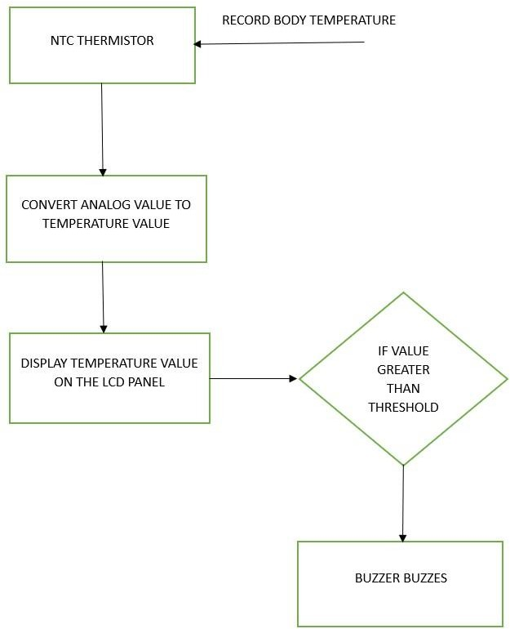

**Fig 3.1: System Architecture**

## DEVELOPMENTAL ENVIRONMENT

* + 1. **HARDWARE REQUIREMENTS**

The hardware requirements may serve as the basis for a contract for the system’s implementation. It should therefore be a complete and consistent specification of the entire system. It is generally used by software engineers as the starting point for the system design.

## Table 3.1 Hardware Requirements

|  |  |
| --- | --- |
| **COMPONENTS** | **SPECIFICATION** |
| NTC Thermistors | -55°C to +125°C |
| Arduino Microcontroller | ATmega328P |
| LCD Display Panel | 16x2 or 20x4 character LCD |
| Buzzer | Piezoelectric buzzer |
| Resistors | Carbon film or metal film (10kΩ) |
| Connecting Wires | Jumper wires (typically 10-20 cm) |
| Breadboard or PCB (Printed Circuit Board) | FR4 for PCB, with copper traces |

* + 1. **SOFTWARE REQUIREMENTS**

These software requirements ensure the IoT Patient Temperature Monitoring System operates efficiently, providing accurate, real-time temperature monitoring and alerts, with potential for future enhancements and integrations.

**Arduino Integrated Development Environment (IDE),** and **Arduino Libraries** would all be required.

## CHAPTER 4 PROJECT DESCRIPTION

* 1. **METHODOLODGY**

The methodology for developing and implementing the IoT Patient Temperature Monitoring System involves several key stages, each designed to ensure the project meets its objectives effectively. These stages include requirement analysis, system design, hardware and software development, integration, testing, deployment, and evaluation. Here’s a detailed breakdown of each stage:

## Requirement Analysis:

The requirement analysis phase aimed to understand the specific needs and challenges faced by healthcare providers in patient temperature monitoring. This involved conducting interviews and surveys with medical professionals to gather insights and reviewing existing monitoring systems to identify gaps. Based on this information, detailed system requirements were defined, including the need for accurate real-time monitoring, alarm thresholds, and user-friendly interface features.

## System Design:

During the system design phase, a comprehensive plan for both hardware and software components was developed. The system architecture was outlined, detailing the sensor subsystem, microcontroller, display unit, and alarm mechanism. Schematics for hardware components and circuit design were created, alongside flowcharts and algorithms for data processing and alert generation. The layout and functionality of the user interface were also meticulously planned.

## Hardware Development:

In the hardware development stage, the physical components of the monitoring system were assembled and configured. Suitable NTC thermistors were selected for precise temperature measurement, and an Arduino microcontroller was chosen for data processing. The LCD display and buzzer alarm components were assembled, and the entire circuit was built and soldered onto a breadboard or PCB, following the design schematics.

## Software Development:

The software development phase involved creating the necessary code for data acquisition, processing, display, and alert generation. This included programming the Arduino microcontroller to read sensor data, process it, and update the LCD display. Algorithms were implemented to monitor temperature thresholds and activate the buzzer alarm as needed. A modular approach was taken to the software design, facilitating easy updates and maintenance.

## Integration:

Integration involved combining the hardware and software components into a single, functional system. The thermistors, microcontroller, LCD display, and buzzer were connected according to the schematics. The software was uploaded to the Arduino microcontroller, and initial data readings were tested. Ensuring seamless communication between all components, the system was verified to display accurate data and trigger alarms appropriately.

## Testing:

The testing phase validated the system's accuracy, reliability, and overall performance. Unit tests checked the functionality of individual components, while system integration tests ensured cohesive operation. Both simulations and real-world tests were conducted to assess the accuracy of temperature readings and the responsiveness of the alarm system. Identified bugs or issues were addressed and resolved during this phase.

## Deployment:

Deployment involved installing and configuring the monitoring system within a healthcare environment such as an ICU. The system was set up according to the planned layout, and training sessions were conducted for healthcare providers to ensure they could effectively use and maintain the system. Integration into the existing workflow was ensured to make the system fully operational.

## Evaluation:

The evaluation phase assessed the system's effectiveness and impact in a real-world setting. Feedback from healthcare providers was gathered to gauge performance and usability. The system's operation was monitored over time to evaluate reliability and effectiveness, and data on response times and patient outcomes were analyzed. This phase helped identify areas for improvement and guided plans for future enhancements.

## MODULE DESCRIPTION

The IoT Patient Temperature Monitoring System project comprises several modular components. The Sensor Subsystem includes NTC thermistors for measuring patient body temperature, which detect variations and transmit data to the Arduino Microcontroller. This central processing unit receives temperature data, processes it, and controls display and alarm functionalities. The Display Unit, featuring an LCD panel, provides real-time temperature readings to healthcare providers, while the Buzzer Alarm emits alerts for abnormal temperature fluctuations. The User Interface enables interaction and customization of alarm settingss

## Sensor Subsystem:

The Sensor Subsystem is responsible for measuring patient body temperature using NTC thermistors. These sensors detect variations in temperature and transmit data to the Arduino Microcontroller for further processing and analysis. By accurately capturing temperature changes, the Sensor Subsystem forms the foundation for real- time monitoring of patient health status.

## Arduino Microcontroller:

At the heart of the IoT Patient Temperature Monitoring System lies the Arduino Microcontroller, serving as the central processing unit. This module receives temperature data from the sensors, processes it according to predefined algorithms, and controls the display of temperature readings on the LCD Display Unit. Additionally, it manages the activation of the Buzzer Alarm in response to abnormal temperature fluctuations, ensuring timely alerts to healthcare providers.

## Display Unit:

The Display Unit, comprising an LCD panel, plays a crucial role in providing real-time temperature readings to healthcare providers. It visually represents the

processed data from the Arduino Microcontroller, enabling quick and easy interpretation of patient temperature trends. The clear and intuitive display interface enhances the effectiveness of healthcare professionals in monitoring patient health status.

## Buzzer Alarm:

The Buzzer Alarm module is designed to emit audible alerts when patient temperature exceeds predefined thresholds. This module enhances situational awareness for healthcare providers, enabling prompt intervention in case of abnormal temperature fluctuations. The audible alerts serve as a vital notification mechanism, ensuring that healthcare personnel can respond swiftly to changes in patient condition.

## User Interface:

The User Interface module facilitates interaction with the monitoring system, allowing healthcare providers to configure system settings and thresholds. Through intuitive controls and interfaces, healthcare personnel can customize alarm parameters to suit individual patient needs. The User Interface module enhances user engagement and adaptability, promoting efficient and personalized patient care.

## Integration Layer:

The Integration Layer serves as the bridge between hardware and software components, ensuring seamless communication and data flow within the monitoring system. This module harmonizes the operation of diverse subsystems, including sensor data acquisition, processing by the Arduino Microcontroller, and display on the LCD panel. By facilitating integration, the system operates cohesively to deliver accurate and reliable temperature monitoring.

## Testing and Validation:

The Testing and Validation module verifies the reliability, accuracy, and performance of the monitoring system under various conditions. Rigorous testing procedures assess the system's functionality, including sensor accuracy, alarm responsiveness, and overall system stability. Through comprehensive validation, the system's efficacy in clinical settings is ensured, fostering confidence in its use for patient care.

## Deployment and Integration:

Deployment and Integration activities involve the installation of the monitoring system in healthcare environments, such as intensive care units. This module encompasses logistical considerations, system setup, and integration with existing healthcare infrastructure. Training sessions for healthcare personnel on system operation and maintenance ensure seamless integration into clinical workflows.

## CHAPTER 5 RESULTS AND DISCUSSIONS

* 1. **OUTPUT**

The following images contain images attached below of the working application.

Example DISPLAY OF PATIENT TEMPERATURE MONITORING SYSTEM

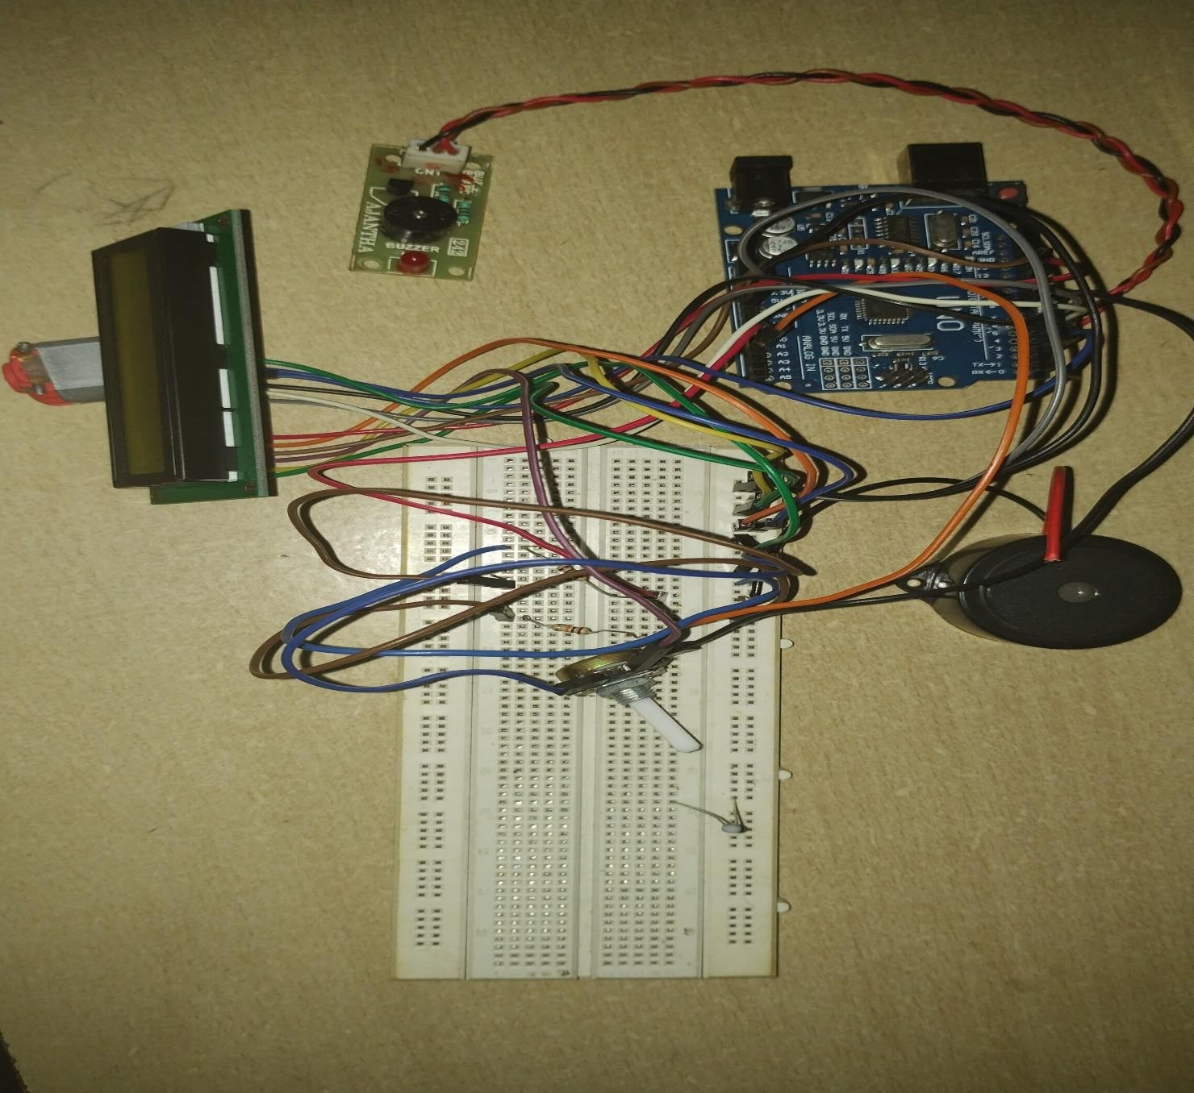

## Training a generation :

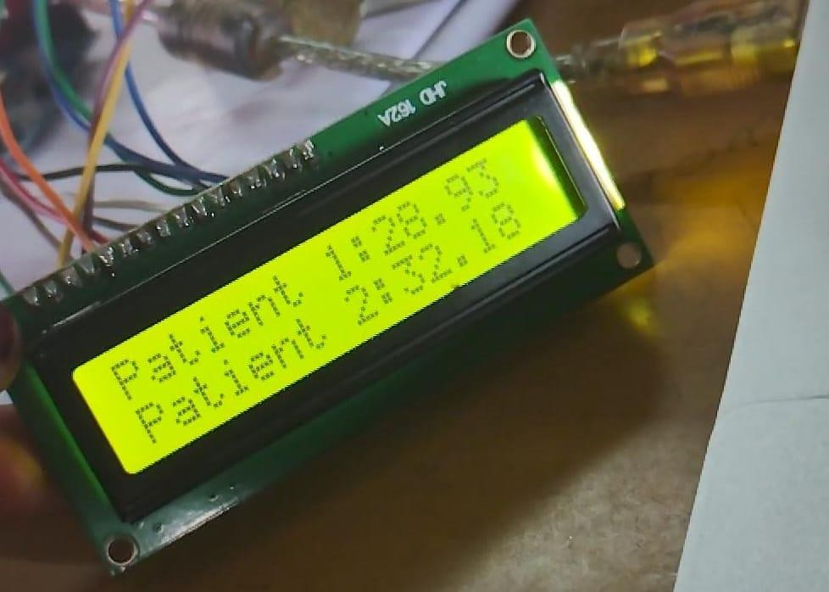

**Fig 5.1: Output**

## RESULT

The IoT Patient Temperature Monitoring System project yielded substantial and impactful results, significantly enhancing patient care in intensive care units (ICUs). The system provided continuous, real-time monitoring of patient body temperature, displaying accurate readings on the LCD panel every second, which facilitated timely and informed decision-making by healthcare providers. The automated alert system effectively notified staff of critical temperature fluctuations, enabling prompt medical interventions and improving patient safety. The reduction in manual temperature measurements allowed nursing staff to focus on other critical tasks, enhancing overall efficiency and patient care.

High accuracy and consistency in temperature readings were achieved through the use of NTC thermistors and the Arduino microcontroller, ensuring reliable data for patient management. The system integrated seamlessly into existing ICU workflows, with user-friendly interfaces and configurable settings, garnering positive feedback from healthcare providers. Its scalability and flexibility made it suitable for various healthcare settings, laying a foundation for future enhancements such as wireless connectivity, hospital information system integration, and advanced data analytics. Overall, the project successfully delivered a reliable, efficient, and user- friendly solution for continuous temperature monitoring, significantly improving patient care and operational efficiency.

## CHAPTER 6

**CONCLUSION AND FUTURE ENHANCEMENT**

## CONCLUSION

In conclusion, the IoT Patient Temperature Monitoring System represents a significant advancement in healthcare technology, addressing the critical need for continuous, automated, and accurate patient temperature monitoring in intensive care settings. By leveraging NTC thermistors, an Arduino microcontroller, an LCD display, and a buzzer alarm, the system ensures real-time visibility of patient temperature and prompt alerts for abnormal fluctuations.

This innovation not only enhances patient safety and care efficiency but also reduces the workload on healthcare professionals, allowing them to focus on more critical tasks. Future enhancements, including integration with hospital information systems, wireless connectivity, advanced data analytics, multi-parameter monitoring, and improved user interfaces, promise to further elevate the system's capabilities. These advancements will enable more comprehensive patient monitoring, predictive insights, and seamless integration into existing healthcare infrastructures. Overall, the IoT Patient Temperature Monitoring System has the potential to revolutionize patient care in intensive care units, providing a robust, reliable, and scalable solution that aligns with the evolving needs of modern healthcare.

## FUTURE ENHANCEMENT

The IoT Patient Temperature Monitoring System can be further enhanced with several advancements to improve its functionality, user experience, and overall impact on healthcare outcomes. Here are some potential future enhancements:

## Integration with Hospital Information Systems (HIS):

Future iterations of the system could integrate with existing hospital information systems to streamline data management and improve accessibility. This integration would enable automatic logging of temperature data into patient records, facilitate remote monitoring by healthcare providers, and support data analytics for better decision-making.

## Wireless Connectivity:

Incorporating wireless connectivity options such as Wi-Fi or Bluetooth for sensor data transmission. Wireless connectivity would eliminate the need for wired connections, improving system flexibility and ease of installation. It would also enable remote monitoring through mobile devices or cloud-based platforms.

## Advanced Data Analytics:

Implementing advanced data analytics and machine learning algorithms to analyze temperature trends and predict potential health issues. Predictive analytics could help in early detection of health problems, enabling proactive intervention and potentially improving patient outcomes. It could also provide personalized insights based on individual patient data.

## APPENDIX

**SOURCE CODE:**

#include <LiquidCrystal.h> const int buzzerPin = 7;

const int tempThreshold = 30; const int ntc1Pin = A0;

const int ntc2Pin = A2; LiquidCrystal lcd(12, 11, 5, 4, 3, 2);

void setup() { lcd.begin(16, 2);

pinMode(buzzerPin, OUTPUT); lcd.print("Patient 1: ");

lcd.setCursor(0, 1);

lcd.print("Patient 2: ");

}

void loop() {

float temp1 = getTemperature(ntc1Pin); float temp2 = getTemperature(ntc2Pin);

lcd.setCursor(10, 0); lcd.print(temp1); lcd.setCursor(10, 1); lcd.print(temp2); delay(1000);

if (temp1 > tempThreshold || temp2 > tempThreshold) { digitalWrite(buzzerPin, HIGH);

delay(1000); digitalWrite(buzzerPin, LOW); delay(1000);

}

}

float getTemperature(int pin) {

int sensorValue = analogRead(pin);

float voltage = sensorValue * (5.0 / 1023.0);

float resistance = (5.0 * 10000.0 / voltage) - 10000.0;

float temperatureCelsius = 1.0 / (log(resistance / 10000.0) / 3977.0 + 1 / 298.15) - 273.15; float temperatureFahrenheit = temperatureCelsius * 9.0 / 5.0 + 32.0;

return temperatureFahrenheit;

}

## REFERENCES

1. Rahaman A, Islam M, Islam M, Sadi M, Nooruddin S. Developing IoT based smart health monitoring systems: a review. Rev Intell Artif. 2019;33:435–

40. <https://doi.org/10.18280/ria.330605>.

1. Riazul Islam SM, Kwak Daehan, Humaun Kabir M, Hossain M, Kwak Kyung-Sup. The Internet of Things for health care: a comprehensive survey. IEEE Access. 2015;3:678–708. <https://doi.org/10.1109/ACCESS.2015.2437951>.
2. Al-Ali AR, Zualkernan IA, Rashid M, Gupta R, Alikarar M. A smart home energy management system using IoT and big data analytics approach. IEEE Trans Consum Electron.
3. A. Dohr, R. Modre-Osprian, M. Drobics, D. Hayn and G. Schreier, "The Internet of Things for Ambient Assisted Living", *Seventh International Conference on Information Technology*, pp. 804-809, 2010.
4. Mois G, Folea S, Sanislav T. Analysis of three IoT-based wireless sensors for environmental monitoring. IEEE Trans Instrum Meas. 2017;66:2056–

64. <https://doi.org/10.1109/TIM.2017.2677619>.

1. Mohammad S. Jassas, Abdullah A. Qasem and Qusay H. Mahmoud, "A Smart System Connecting e-Health Sensors and the Cloud A Smart System Connecting e-Health Sensors and the Cloud", *Proceeding of the IEEE 28th Canadian Conference on Electrical and Computer Engineering Halifax*, pp. 712-716, May 3-6, 2015.
2. K. Mathan Kumar and R.S. Venkatesan, "A Design Approach to Smart Health Monitoring Using Android Mobile Devices", *IEEE International Conference on Advanced Communication Control and Computing Technologies (ICACCCT)*, pp. 1740-1744, 2014.
3. Shubham Banka, Isha Madan and S.S. Saranya, Smart Healthcare Monitoring using IoT. International Journal of Applied Engineering Research ISSN 0973-4562 Volume 13, Number 15, pp. 11984-11989, 2018.
4. P. Rizwan, K. Suresh. Design and development of low investment smart hospital using Internet of things through innovative approaches, Biomedical Research. 28(11) (2017).